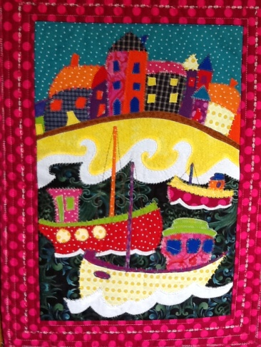
Messing About With Boats

Requirements List

1 x Fat ¼ Sky

1 x Fat ¼ Sea

I have used about 20 different fabrics in mine.
I bought some new ones and used some that I already had. (Only small amounts are used but what is left can be used up on future projects). Bring your scrap bag always useful for little pieces.

- x metre Bonda web, steam a seam or whatever you like to use.

1 x Fat ¼ Batting

1 x Fat ¼ Backing Fabric

1 x Fat ¼ Stabilizer

Borders 14 cms

A selection of threads I like to use the variegated threads.

Sewing machine

Open toe foot (This is a foot that has no bar in the centre which gives you a
clear view of what you are doing.)

Scissors

Ironing pad if you have one a folded towel will do

Travel Iron

Pencil

If there is anything you need help with my email is treaselane@hotmail.co.uk

