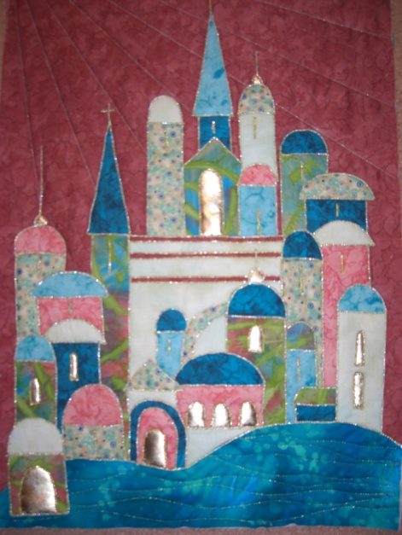
Xmas Hanging
Requirements List

1 x Fat ¼ Background Fabric
7 x pieces of fabric for buildings. I bought 7 fat ¼ surplus can be used on another project or it’s a good way to use up scraps that you have.

Fabric for bottom of buildings 5” x 16”

Gold fabric for windows.

Bonda web 1 Metre or steam A seam

Batting 20 x 17

Thread of your choice for couching. (I used a metallic perle cotton)

Thread for sewing couching thread (This will be used in the sewing machine to attach the thicker thread).

Sharpe point scissors.

Sewing machine

Open toe foot or cording foot.

Pencil.

Travel iron and ironing pad if you have one. A folded towel is a good alternative for an ironing pad.

