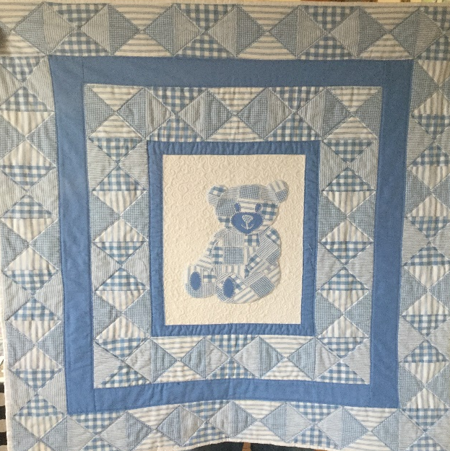
Baby Quilt Requirements List

¼ Square triangles & Teddy 4 x Fat 1/4

Sashing ½ Metre

Fabric centre Panel Background 1 x Fat ¼

Stabilizer ¼ Metre

Bondaweb or Heat & Bond ¼ Metre

Batting 1 ¼ Metres

Backing 1 ¼ Metres

Threads

Sewing Machine

Open toe foot

¼ Foot

