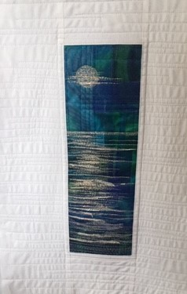
Sea Scape Organza
Sea Scape measures 4 x 13
With borders 13 x 22

Felt or Wadding 14 x 23
Background fabric for under the organza 4 ½ x 13 ½ this can be a really vivid colour as we knock it back with organza.
Organza small pieces needed. I will have some organza with me on the day. Etsy is a good place to look if you are buying small pieces.

lame fabric or any sparkly fabric colour of your choice This link is the sort of thing you want. Tiny amount needed for waves
https://www.ebay.co.uk/itm/Tricot-Metallic-Foil-Lame-Costume-non-Stretch-wear-Fabric-110cm-Wide-Mtex-MK1087/192905528165?_trksid=p2485497.m4902.l9144

Angelina Fibres 1 Pack colour of you choice. https://www.ebay.co.uk/sch/i.html?_from=R40&_trksid=p2047675.m570.l1311&_nkw=angelina+fibre&_sacat=0
Small amount of white net or any other fabrics you think might work out of your stash. I will have some with me as only a tiny amount is needed.

Heat and bond or bonda web whichever you prefer a piece roughly 20 x 20 will be plenty.

White fabric for borders 4 ½ wide we will cut to length on the day.

Silver thread I used metallic or thread colour to go with your choice of fabrics.

White thread

Thread to match your background fabric.

Non stick iron sheet greaseproof paper will do
Sewing machine
Iron and Ironing pad.
Cutting Mat / Rotary cutter/ ruler

