Trees in Embroidery hoop.
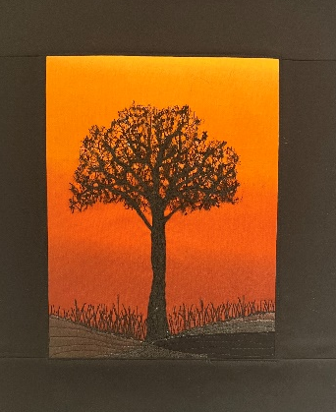
Requirements

Embroidery hoop roughly between 8 – 10 “.
Fat ¼ fabric for background. If you want to do several different colour trees then bring more.
20 x 16 “roughly felt or wadding. Again please bring more if you want to do more.
Border fabric Fat ¼ or pieces that you have that will do.
Small quantity of organza or fabric if you prefer for the foreground.
Small amount of heat and bond for bonding the foreground pieces.
Selection of threads depending on what colour you want to stitch your tree.
Sewing Machine
Open toe foot/ Free motion foot.
Spider web fabric I will bring some with me on the day for you to use at a small fee. I have put a link to the sort of stuff you need as you may have some or may wish to get some.
Spider Web Net On A Roll 38cm x 10m 8 Colours Wrapping Fabric Arts Craft Decor | eBay

