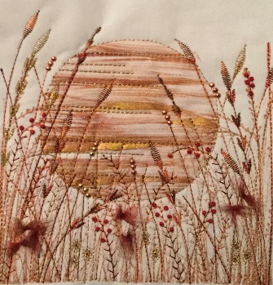
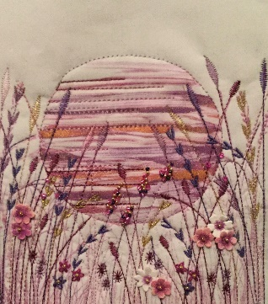
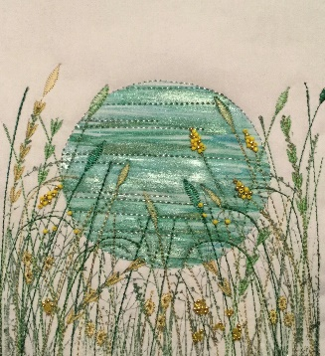
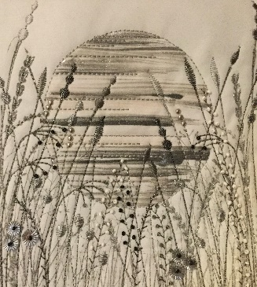

Stamp & Stitch
Requirements
1 x Metre white cotton fabric (Link to what I use but any fabric will do) White Egyptian Cotton Fabric Bundles (empressmills.co.uk)
1 x Metre Freezer Paper
Pen, scissors
1 X Metre Felt / Wadding (I use felt)
Piece of sponge for painting
Kitchen Roll
Something soft to use for printing I use an old piece of felt but newspaper will be fine.
Sewing Machine with some decorative stitches and open toe foot
Selection of threads to use for the decorative stitches on your machine
Paint. You could use fabric paint or Acrylic paint (Link to what I use) Amazon.co.uk : jacquard lumiere paint
A piece of fabric/felt to practice stitching
Embellishment’s I have used paper flowers, Organza Scraps, beads
Little Birdie Classic Daisies 60 Pieces | Hobbycraft

The following I will have these for you to use on the day – unless you wish to purchase/bring your own
- Paint tray / Brushes
- Gelli Plate if you have one or a piece of plastic will do Amazon.co.uk : gelli plate
- I will have plastic stamps for you to use on the day. But if you want to have a look google clear plastic stamps.
- 1 x Ink pad for stamping if you have one, I will have mine with me for you to use.

For Sat Nav use NP7 8PG or visit my website www.patchworklane.co.uk and follow the map instructions.

