Landscape Requirements
- Scraps of fabric Cotton/ Organza/ Lace anything that you have roughly 3 x 12 inches a selection of light mediums and darks in your chosen colours. Approximately 12 of each. It’s a good idea to bring your scrap box. Your sky fabric needs to roughly be 4 ½ x 12 these sizes are for a big one.

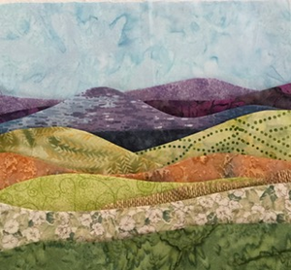
- 1 Piece of felt or wadding 15 x 12 (If you wish to do more than 1 bring more) These sizes are for a big one

- A varied selection of threads variegated machine embroidery

- Sewing machine

- Open toe foot

- Free motion foot

- Small amount of heat and bond

- Iron pad & iron

- Starch

10) Cutting mat / Rotary cutter

- Basic sewing kit

