Stitched Poppy
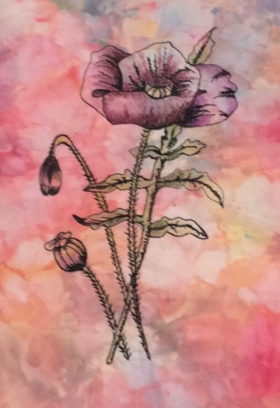
- 1 x Fat ¼ Background fabric

- 1 x Fat ¼ White Net

- 1 X Fat ¼ Felt or wadding.

- 1 x Fat ¼ Heat & Bond

- Colouring medium of your choice Inktense Blocks / Pencils/ Fabric paint (I will bring some on the day for you to use)

- Black thread or colour of your choice

- Sewing machine

- Free motion foot

