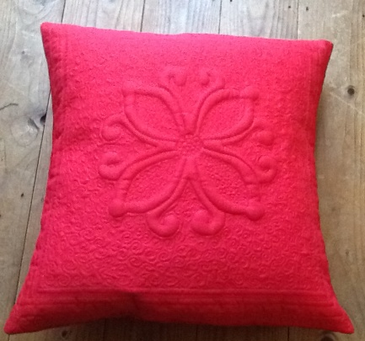
Trapunto

Requirements

½ Metre Plain fabric for cushion

High loft wadding 20” x 20” (Polyester)

Ordinary wadding of your choice 20” x 20”

Backing fabric 20” x 20” (This will be inside the cushion so
it will not be seen)

Machine thread to match your fabric, for quilting

Dissolvable thread

Sewing Machine

Open toe foot

Embroidery/ Free machine foot

Light box if you have one

