Christmas Tree Skirt
Requirements

- 1 ½ Metres Background Fabric

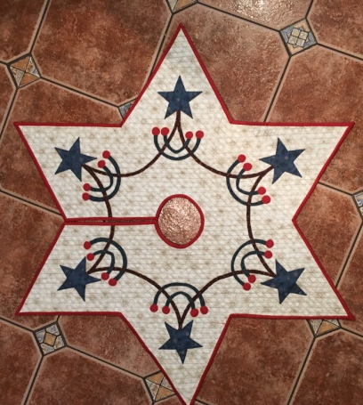
- 1 ½ Metres Backing Fabric

- 1 ½ Metres Wadding or Felt

- ¾ Metre binding fabric

- 3 Fat 1/4s fabric Applique

- ½ Metre Heat & Bond or Bonda Web

- Thread

- Pen / Pencil

- Sewing Machine

- Open Toe foot if you have one

- Ruler

- Rotary Cutter

- Iron & Iron pad if you have one. (There will be some in the shop for you to use)

