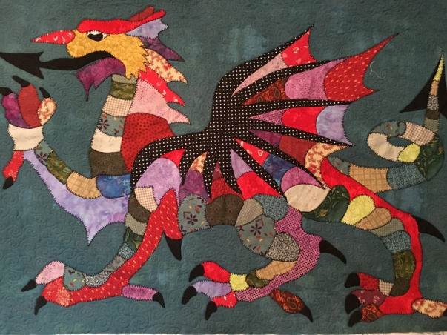
Dragon Wall Hanging
Requirements

- 1 Metre Background fabric

- 1 Metre wadding or felt for backing.

- 1 Metre backing fabric.

- 1 Metre medium weight stabilizer.

- 1 ½ Metres heat & bond or bonda web which ever you prefer to use.

- Selection of fabrics for the dragon. I made mine from scraps. The pieces are not very big a good selection of fat 1/4s would do.

- Thread for blanket stitch

- Scissors

- Pen / pencil

- Iron & Iron pad large towel will do

- Scissors

- Sewing Machine

- Open toe foot

