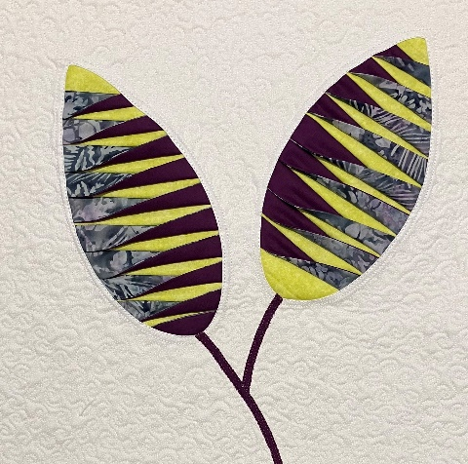
Pleated Cushion / Wall Hanging
Requirements
2 x Fat ¼ s in contrast fabric
1 x Fat ¼ in complementary fabric
½ Metre fabric for background and backing.
20 “square of wadding
Thread to match your background fabric
Stitch and tear roughly 2 @ 12 x 6 ½ “
Sewing machine
Cutting mat / ruler/ rotary cutter
Small amount heat & bond for stems

