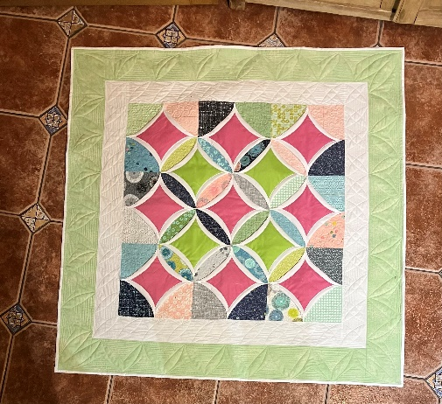
Charm Pack Cathedral Windows
Requirements

1 x Charm Pack or 36 x 5-inch squares of fabric (This is the background squares in the picture.

2 x Fat ¼ s This is for the plain pink 9 x 5inch squares.
Green 4 x 5-inch squares in the picture.

1 ½ Metres of fabric, this is the white fabric in pic curved edge and first border. You will need 52 x 5-inch squares.

¾ Metre of second border fabric, Green in picture.

1 ½ Metre of Wadding

Cutting Mats
Rotary Cutter
Ruler
Thread
Sewing machines
Pins etc

These requirements are approximate.
Mine measures 42 x 42” if you want to make a bigger one you could double the amount or add more borders.

If the fabrics could be cut as measurements above before the class that would give us much more time to sew.
If you are not sure about cutting contact me at www.treaselane@hotmail.co.uk

